|  |  |  |  |
| --- | --- | --- | --- |
| Angol szóbeli vizsga | Középszint | 1.Vizsgafeladat | Bevezető interjú |

**1. Vizsgafeladat -vizsgáztatói példány**

**Bevezetés (nem értékeljük)**

Mielőtt a tényleges szóbeli vizsga elkezdődik, egy rövid (kb. egyperces) bemelegítő beszélgetés szükséges.

Vizsgáztató:

* Did you sleep well?
* How are you today?
* What did you do yesterday evening?
* When did you get up?
* Is it the first time you are taking an exam?
* How did you come here?
* Are you planning to have a party after the exam?
* ( If “no”: ) What are you going to do after the exam?

Now I am going to ask you a few questions. If you can’t understand me, I can repeat the question once. Let’s get started:

**Tényleges vizsga (ettől a résztől értékeljük):**

Vizsgáztató:

We are going to talk about jobs.

A At what age do people usually begin to work in Hungary?

**People usually start to work after they finish secondary school or university. They are between 19 and 24. They retire at the age of 64.**

B Do you think it is more important to make a lot of money or to enjoy your job?

**I think it’s important to enjoy your job. I would like a job which I enjoy to do and I can earn a lot of money. I’d like to be a … and work …**

C What are the advantages and disadvantages of having a summer job?

**The advantages are: you earn money, you get work experience, you make new friends, you …**

**The disadvantages are: you have less free time, you become tired by the end of the day, you have to get up early, you miss your friends, you can’t spend enough time with your family.**

Thank you very much.

That’s the end of your first task.

|  |  |  |  |
| --- | --- | --- | --- |
| Angol szóbeli vizsga | Középszint | 2.Vizsgafeladat | Szituációs feladat |

# 2. Vizsgafeladat - vizsgáztatói példány

A vizsgáztató átadja a vizsgázónak a vizsgázó feladatlapját. A vizsgázó kb. fél percig készülhet.

A vizsgázó példánya

You feel ill so you decide to visit the doctor.

- Explain what symptoms you have.

- Answer the doctor’s questions.

- Ask what you should do to recover.

- Ask what medicine you have to take.

Prompts for the interlocutor:

• Good morning, sit down!

* **Good morning.**

• What’s your problem? What can I do for you?  
 **- I have a sore throat, my nose is running and I have a headache.**  
• Do you have temperature?

* **Yes, I do. I have a fever.**

• How long have you been unwell?

* **I have been unwell for 3 days.**

• I see. Get undressed, please. I have to examine you.

* **Allright. What should I do to recover?**

• Well, I think you should stay at home for a few days.

* **What medicine do I have to take?**
* You should drink a lot of tea, take some painkiller… If you feel worse, come back.
* **Thank you, goodbye.**

|  |  |  |  |
| --- | --- | --- | --- |
| Angol szóbeli vizsga | Középszint | 3.Vizsgafeladat | Önálló témakifejtés |

#### **3. Vizsgafeladat - vizsgáztatói példány**

A vizsgáztató átadja a vizsgázónak a vizsgázó feladatlapját. A vizsgázó kb. fél percig készülhet.

# A vizsgázó példánya

Compare and contrast the two pictures. Include the following points:

- The most important differences between winter and summer.

- What are the four seasons in Hungary?

- What are the good and bad aspects of them?

- What activities can people do in the different seasons?

**I can see winter and summer in the pictures. In winter the weather is cold, icy, snowy. In the summer the weather is hot and sunny.**

**There are four seasons in Hungary: spring, summer, autumn and winter. My favourite season is …, because…**

**Spring is warm, flowers bloom, everything is green. The nature starts to live then.**

**In summer there is no school, it’s holiday time. In autumn the leaves fall from the trees. In winter the nature sleeps.**

**In spring you can go hiking and cycling. In summer you can go to the beach, do some water sports. In autumn you can go hiking, forests are really colourful then. I winter you can go skiing and sledging if there is snow.**

**Prompts for the interlocutor:**

* What is the weather like in summer / autumn…etc.?
* What sort of clothes should people wear in summer/autumn…etc.?
* What happens to nature during the year?

**THANK YOU. THIS IS THE END OF YOUR EXAMINATION.**

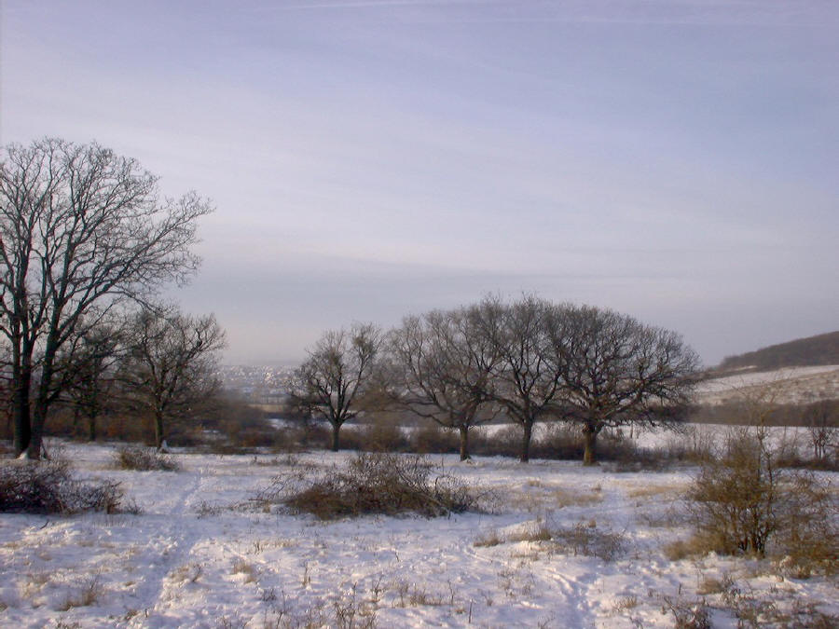

**

|  |  |  |  |
| --- | --- | --- | --- |
| Angol szóbeli vizsga | Középszint | 2.Vizsgafeladat | Szituációs feladat |

# 2. Vizsgafeladat - vizsgázói példány

A vizsgázó példánya

You feel ill so you decide to visit the doctor.

- Explain what symptoms you have. (a headache, a sore throat, a running nose, bad cough, fever…)

- Answer the doctor’s questions.

- Ask what you should do to recover.

- Ask what medicine you have to take.

|  |  |  |  |
| --- | --- | --- | --- |
| Angol szóbeli vizsga | Középszint | 3.Vizsgafeladat | Önálló témakifejtés |

#### **3. Vizsgafeladat - vizsgázói példány**

# A vizsgázó példánya

Compare and contrast the two pictures. Include the following points:

- The most important differences between winter and summer.

- What are the four seasons in Hungary?

- What are the good and bad aspects of them?

- What activities can people do in the different seasons?



